Хандажевский А.Д.

ПР23/1

Лабораторная работа №2

Тема: **«Разработка модульной структуры проекта»**

Внешний вид базы данных:  
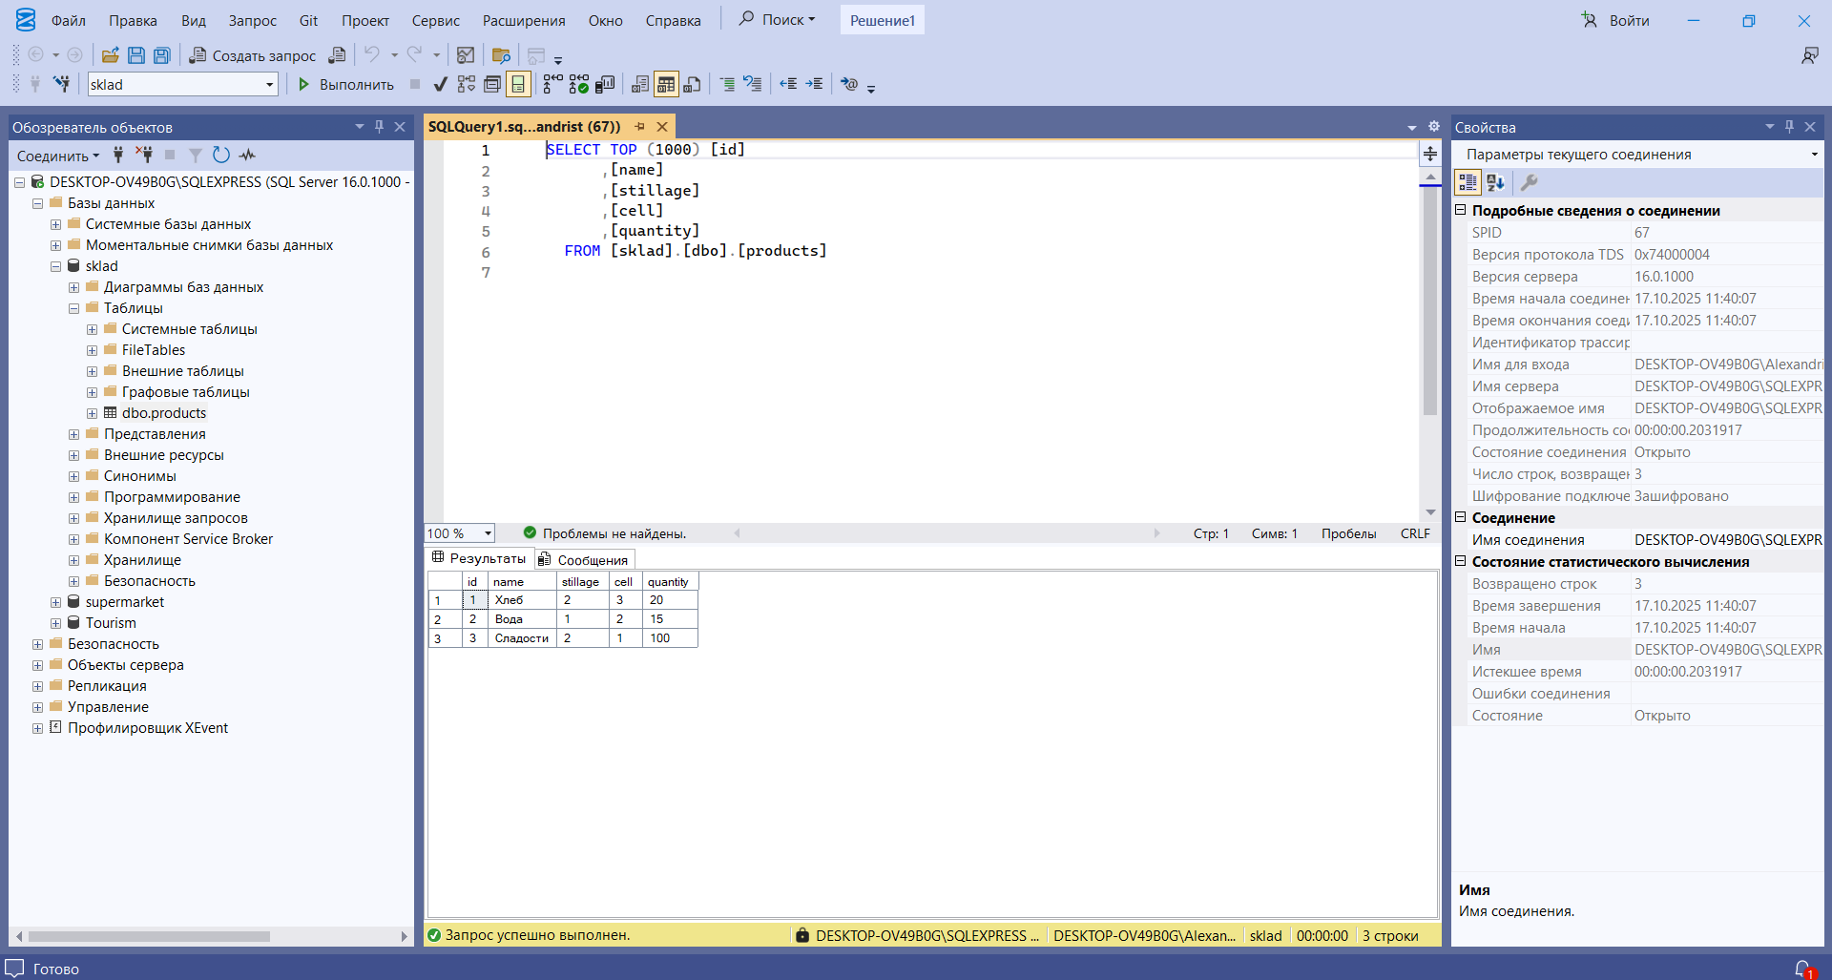

Рисунок 1

Литстнг кода программы:

using System;

using System.Collections.Generic;

using System.ComponentModel;

using System.Data;

using System.Data.SqlClient;

using System.Drawing;

using System.IO;

using System.Linq;

using System.Text;

using System.Threading.Tasks;

using System.Windows.Forms;

namespace LR2_ISRPO

{

public partial class Sklad : Form

{

public Sklad()

{

InitializeComponent();

this.Load += Sklad_Load;

Start();

}

private DataGridView dataGridViewProducts;

private TextBox textBoxId;

private TextBox textBoxName;

private TextBox textBoxStillage;

private TextBox textBoxCell;

private TextBox textBoxQuantity;

private Button buttonAdd;

private Button buttonUpdate;

private Button buttonDelete;

private Button buttonSaveToFile;

private TextBox textBoxSearchName;

private Button buttonSearchName;

private TextBox textBoxSearchStillage;

private TextBox textBoxSearchCell;

private Button buttonSearchCoordinates;

private Button buttonRefresh;

private string connectionString = @"Data Source=DESKTOP-OV49B0G\SQLEXPRESS;Initial Catalog=sklad;Integrated Security=True";

private void Sklad_Load(object sender, EventArgs e)

{

LoadData();

}

private void Start()

{

this.Width = 800;

this.Height = 600;

this.Text = "Управление складом";

// DataGridView - создаем первым

dataGridViewProducts = new DataGridView();

dataGridViewProducts.Location = new Point(20, 20);

dataGridViewProducts.Size = new Size(600, 200);

dataGridViewProducts.SelectionMode = DataGridViewSelectionMode.FullRowSelect;

dataGridViewProducts.ReadOnly = true;

dataGridViewProducts.AutoGenerateColumns = true;

this.Controls.Add(dataGridViewProducts);

// Остальные элементы управления...

// Поля ввода с метками

Label labelId = new Label();

labelId.Text = "ID:";

labelId.Location = new Point(20, 240);

labelId.Size = new Size(30, 20);

this.Controls.Add(labelId);

textBoxId = new TextBox();

textBoxId.Location = new Point(50, 240);

textBoxId.Size = new Size(50, 20);

this.Controls.Add(textBoxId);

Label labelName = new Label();

labelName.Text = "Название:";

labelName.Location = new Point(110, 240);

labelName.Size = new Size(60, 20);

this.Controls.Add(labelName);

textBoxName = new TextBox();

textBoxName.Location = new Point(170, 240);

textBoxName.Size = new Size(100, 20);

this.Controls.Add(textBoxName);

Label labelStillage = new Label();

labelStillage.Text = "Стеллаж:";

labelStillage.Location = new Point(280, 240);

labelStillage.Size = new Size(50, 20);

this.Controls.Add(labelStillage);

textBoxStillage = new TextBox();

textBoxStillage.Location = new Point(330, 240);

textBoxStillage.Size = new Size(50, 20);

this.Controls.Add(textBoxStillage);

Label labelCell = new Label();

labelCell.Text = "Ячейка:";

labelCell.Location = new Point(390, 240);

labelCell.Size = new Size(40, 20);

this.Controls.Add(labelCell);

textBoxCell = new TextBox();

textBoxCell.Location = new Point(430, 240);

textBoxCell.Size = new Size(50, 20);

this.Controls.Add(textBoxCell);

Label labelQuantity = new Label();

labelQuantity.Text = "Кол-во:";

labelQuantity.Location = new Point(490, 240);

labelQuantity.Size = new Size(40, 20);

this.Controls.Add(labelQuantity);

textBoxQuantity = new TextBox();

textBoxQuantity.Location = new Point(530, 240);

textBoxQuantity.Size = new Size(50, 20);

this.Controls.Add(textBoxQuantity);

// Кнопки управления

buttonAdd = new Button();

buttonAdd.Location = new Point(20, 270);

buttonAdd.Size = new Size(75, 23);

buttonAdd.Text = "Добавить";

buttonAdd.Click += ButtonAdd_Click;

this.Controls.Add(buttonAdd);

buttonUpdate = new Button();

buttonUpdate.Location = new Point(100, 270);

buttonUpdate.Size = new Size(75, 23);

buttonUpdate.Text = "Изменить";

buttonUpdate.Click += ButtonUpdate_Click;

this.Controls.Add(buttonUpdate);

buttonDelete = new Button();

buttonDelete.Location = new Point(180, 270);

buttonDelete.Size = new Size(75, 23);

buttonDelete.Text = "Удалить";

buttonDelete.Click += ButtonDelete_Click;

this.Controls.Add(buttonDelete);

buttonSaveToFile = new Button();

buttonSaveToFile.Location = new Point(260, 270);

buttonSaveToFile.Size = new Size(100, 23);

buttonSaveToFile.Text = "Сохранить в файл";

buttonSaveToFile.Click += ButtonSaveToFile_Click;

this.Controls.Add(buttonSaveToFile);

// Поиск по названию

Label labelSearchName = new Label();

labelSearchName.Location = new Point(20, 310);

labelSearchName.Size = new Size(100, 20);

labelSearchName.Text = "Поиск по названию:";

this.Controls.Add(labelSearchName);

textBoxSearchName = new TextBox();

textBoxSearchName.Location = new Point(130, 310);

textBoxSearchName.Size = new Size(100, 20);

this.Controls.Add(textBoxSearchName);

buttonSearchName = new Button();

buttonSearchName.Location = new Point(240, 310);

buttonSearchName.Size = new Size(75, 23);

buttonSearchName.Text = "Найти";

buttonSearchName.Click += ButtonSearchName_Click;

this.Controls.Add(buttonSearchName);

// Поиск по координатам

Label labelSearchCoordinates = new Label();

labelSearchCoordinates.Location = new Point(20, 350);

labelSearchCoordinates.Size = new Size(100, 20);

labelSearchCoordinates.Text = "Поиск по координатам:";

this.Controls.Add(labelSearchCoordinates);

Label labelSearchStillage = new Label();

labelSearchStillage.Location = new Point(130, 350);

labelSearchStillage.Size = new Size(50, 20);

labelSearchStillage.Text = "Стеллаж:";

this.Controls.Add(labelSearchStillage);

textBoxSearchStillage = new TextBox();

textBoxSearchStillage.Location = new Point(180, 350);

textBoxSearchStillage.Size = new Size(50, 20);

this.Controls.Add(textBoxSearchStillage);

Label labelSearchCell = new Label();

labelSearchCell.Location = new Point(240, 350);

labelSearchCell.Size = new Size(40, 20);

labelSearchCell.Text = "Ячейка:";

this.Controls.Add(labelSearchCell);

textBoxSearchCell = new TextBox();

textBoxSearchCell.Location = new Point(280, 350);

textBoxSearchCell.Size = new Size(50, 20);

this.Controls.Add(textBoxSearchCell);

buttonSearchCoordinates = new Button();

buttonSearchCoordinates.Location = new Point(340, 350);

buttonSearchCoordinates.Size = new Size(75, 23);

buttonSearchCoordinates.Text = "Найти";

buttonSearchCoordinates.Click += ButtonSearchCoordinates_Click;

this.Controls.Add(buttonSearchCoordinates);

// Кнопка обновления

buttonRefresh = new Button();

buttonRefresh.Location = new Point(545, 270);

buttonRefresh.Size = new Size(75, 23);

buttonRefresh.Text = "Обновить";

buttonRefresh.Click += ButtonRefresh_Click;

this.Controls.Add(buttonRefresh);

// Подписываемся на событие после полной инициализации dataGridViewProducts

dataGridViewProducts.SelectionChanged += DataGridViewProducts_SelectionChanged;

}

private void LoadData()

{

try

{

using (SqlConnection connection = new SqlConnection(connectionString))

{

connection.Open();

string query = "SELECT * FROM products";

SqlDataAdapter adapter = new SqlDataAdapter(query, connection);

DataTable table = new DataTable();

adapter.Fill(table);

dataGridViewProducts.DataSource = table;

}

}

catch (Exception ex)

{

MessageBox.Show("Ошибка загрузки данных: " + ex.Message);

}

}

private void DataGridViewProducts_SelectionChanged(object sender, EventArgs e)

{

if (dataGridViewProducts != null && dataGridViewProducts.SelectedRows.Count > 0)

{

DataGridViewRow row = dataGridViewProducts.SelectedRows[0];

textBoxId.Text = row.Cells["id"].Value?.ToString() ?? "";

textBoxName.Text = row.Cells["name"].Value?.ToString() ?? "";

textBoxStillage.Text = row.Cells["stillage"].Value?.ToString() ?? "";

textBoxCell.Text = row.Cells["cell"].Value?.ToString() ?? "";

textBoxQuantity.Text = row.Cells["quantity"].Value?.ToString() ?? "";

}

}

// Остальные методы остаются без изменений...

private void ButtonAdd_Click(object sender, EventArgs e)

{

if (string.IsNullOrWhiteSpace(textBoxId.Text) || string.IsNullOrWhiteSpace(textBoxName.Text))

{

MessageBox.Show("Заполните обязательные поля ID и Название");

return;

}

try

{

using (SqlConnection connection = new SqlConnection(connectionString))

{

connection.Open();

string query = "INSERT INTO products (id, name, stillage, cell, quantity) VALUES (@id, @name, @stillage, @cell, @quantity)";

SqlCommand command = new SqlCommand(query, connection);

command.Parameters.AddWithValue("@id", int.Parse(textBoxId.Text));

command.Parameters.AddWithValue("@name", textBoxName.Text);

command.Parameters.AddWithValue("@stillage", string.IsNullOrWhiteSpace(textBoxStillage.Text) ? (object)DBNull.Value : int.Parse(textBoxStillage.Text));

command.Parameters.AddWithValue("@cell", string.IsNullOrWhiteSpace(textBoxCell.Text) ? (object)DBNull.Value : int.Parse(textBoxCell.Text));

command.Parameters.AddWithValue("@quantity", string.IsNullOrWhiteSpace(textBoxQuantity.Text) ? (object)DBNull.Value : int.Parse(textBoxQuantity.Text));

command.ExecuteNonQuery();

}

LoadData();

ClearInputFields();

}

catch (Exception ex)

{

MessageBox.Show("Ошибка добавления: " + ex.Message);

}

}

private void ButtonUpdate_Click(object sender, EventArgs e)

{

if (dataGridViewProducts.SelectedRows.Count == 0)

{

MessageBox.Show("Выберите продукт для изменения");

return;

}

try

{

using (SqlConnection connection = new SqlConnection(connectionString))

{

connection.Open();

string query = "UPDATE products SET name = @name, stillage = @stillage, cell = @cell, quantity = @quantity WHERE id = @id";

SqlCommand command = new SqlCommand(query, connection);

command.Parameters.AddWithValue("@id", int.Parse(textBoxId.Text));

command.Parameters.AddWithValue("@name", textBoxName.Text);

command.Parameters.AddWithValue("@stillage", string.IsNullOrWhiteSpace(textBoxStillage.Text) ? (object)DBNull.Value : int.Parse(textBoxStillage.Text));

command.Parameters.AddWithValue("@cell", string.IsNullOrWhiteSpace(textBoxCell.Text) ? (object)DBNull.Value : int.Parse(textBoxCell.Text));

command.Parameters.AddWithValue("@quantity", string.IsNullOrWhiteSpace(textBoxQuantity.Text) ? (object)DBNull.Value : int.Parse(textBoxQuantity.Text));

command.ExecuteNonQuery();

}

LoadData();

}

catch (Exception ex)

{

MessageBox.Show("Ошибка изменения: " + ex.Message);

}

}

private void ButtonDelete_Click(object sender, EventArgs e)

{

if (dataGridViewProducts.SelectedRows.Count == 0)

{

MessageBox.Show("Выберите продукт для удаления");

return;

}

try

{

using (SqlConnection connection = new SqlConnection(connectionString))

{

connection.Open();

string query = "DELETE FROM products WHERE id = @id";

SqlCommand command = new SqlCommand(query, connection);

command.Parameters.AddWithValue("@id", int.Parse(textBoxId.Text));

command.ExecuteNonQuery();

}

LoadData();

ClearInputFields();

}

catch (Exception ex)

{

MessageBox.Show("Ошибка удаления: " + ex.Message);

}

}

private void ButtonSaveToFile_Click(object sender, EventArgs e)

{

try

{

using (SaveFileDialog saveFileDialog = new SaveFileDialog())

{

saveFileDialog.Filter = "Text files (*.txt)|*.txt|All files (*.*)|*.*";

if (saveFileDialog.ShowDialog() == DialogResult.OK)

{

using (StreamWriter writer = new StreamWriter(saveFileDialog.FileName))

{

foreach (DataGridViewRow row in dataGridViewProducts.Rows)

{

if (!row.IsNewRow)

{

writer.WriteLine($"{row.Cells["id"].Value}\t{row.Cells["name"].Value}\t{row.Cells["stillage"].Value}\t{row.Cells["cell"].Value}\t{row.Cells["quantity"].Value}");

}

}

}

MessageBox.Show("Данные сохранены в файл");

}

}

}

catch (Exception ex)

{

MessageBox.Show("Ошибка сохранения в файл: " + ex.Message);

}

}

private void ButtonSearchName_Click(object sender, EventArgs e)

{

if (string.IsNullOrWhiteSpace(textBoxSearchName.Text))

{

MessageBox.Show("Введите название для поиска");

return;

}

try

{

using (SqlConnection connection = new SqlConnection(connectionString))

{

connection.Open();

string query = "SELECT * FROM products WHERE name LIKE @name";

SqlDataAdapter adapter = new SqlDataAdapter(query, connection);

adapter.SelectCommand.Parameters.AddWithValue("@name", "%" + textBoxSearchName.Text + "%");

DataTable table = new DataTable();

adapter.Fill(table);

dataGridViewProducts.DataSource = table;

}

}

catch (Exception ex)

{

MessageBox.Show("Ошибка поиска: " + ex.Message);

}

}

private void ButtonSearchCoordinates_Click(object sender, EventArgs e)

{

if (string.IsNullOrWhiteSpace(textBoxSearchStillage.Text) || string.IsNullOrWhiteSpace(textBoxSearchCell.Text))

{

MessageBox.Show("Введите стеллаж и ячейку для поиска");

return;

}

try

{

using (SqlConnection connection = new SqlConnection(connectionString))

{

connection.Open();

string query = "SELECT * FROM products WHERE stillage = @stillage AND cell = @cell";

SqlDataAdapter adapter = new SqlDataAdapter(query, connection);

adapter.SelectCommand.Parameters.AddWithValue("@stillage", int.Parse(textBoxSearchStillage.Text));

adapter.SelectCommand.Parameters.AddWithValue("@cell", int.Parse(textBoxSearchCell.Text));

DataTable table = new DataTable();

adapter.Fill(table);

dataGridViewProducts.DataSource = table;

}

}

catch (Exception ex)

{

MessageBox.Show("Ошибка поиска: " + ex.Message);

}

}

private void ButtonRefresh_Click(object sender, EventArgs e)

{

LoadData();

ClearInputFields();

textBoxSearchName.Clear();

textBoxSearchStillage.Clear();

textBoxSearchCell.Clear();

}

private void ClearInputFields()

{

textBoxId.Clear();

textBoxName.Clear();

textBoxStillage.Clear();

textBoxCell.Clear();

textBoxQuantity.Clear();

}

// Хороший код

public string CountLines(string filePath)

{

try

{

int lineCount = 0;

using (var reader = new StreamReader(filePath))

{

while (reader.ReadLine() != null)

{

lineCount++;

}

}

return Convert.ToString(lineCount);

}

catch (FileNotFoundException)

{

Console.WriteLine("Файл не найден");

return null;

}

catch (IOException ex)

{

Console.WriteLine($"Ошибка ввода-вывода: {ex.Message}");

return null;

}

}

}

}

Результат работы программы:

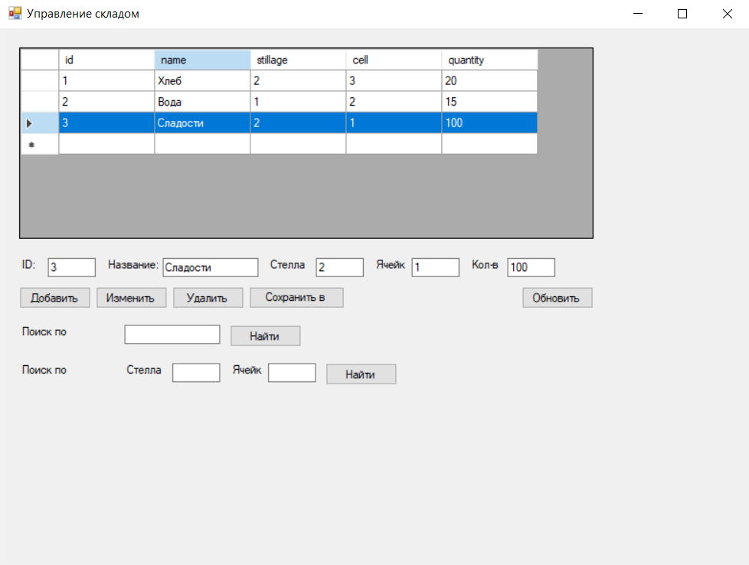

Рисунок 2

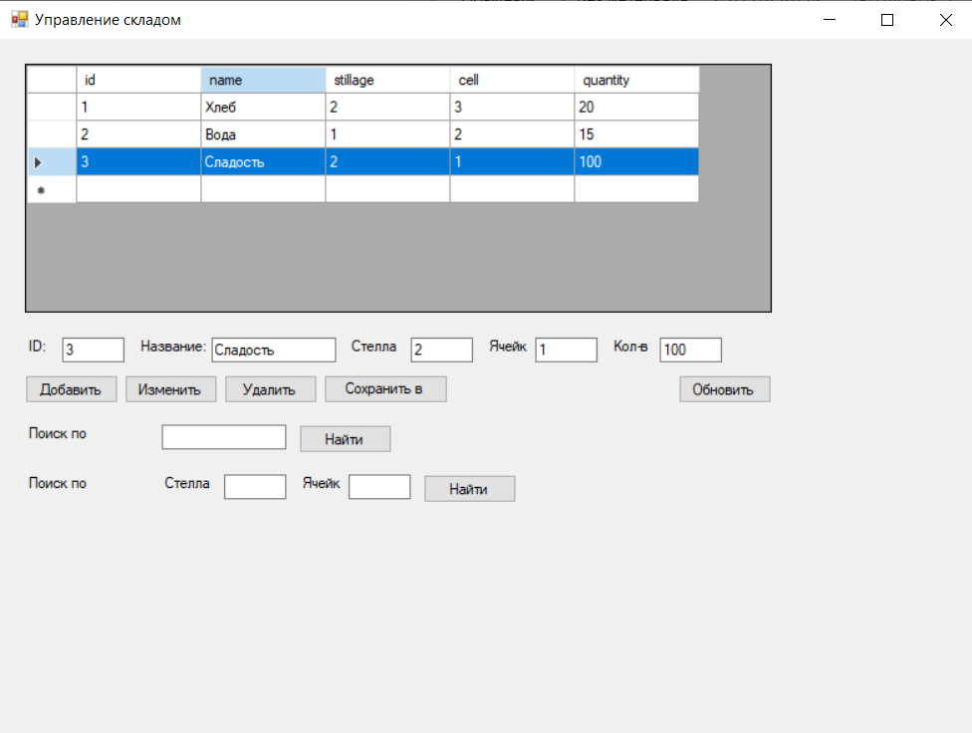

Рисунок 3 – Изменение данных